Jeffrey Dean

Regression Methods Final Project-

Liquidity Trap Potential USA/European Union

Introduction

In economic terms, a liquidity trap is an occurrence in monetary policy when a central bank reduces long term interest rates in order to expand the economy and the market produces a less than expected change in behavior. Lower interest rates encourage households and firms to borrow as costs of doing so are reduced, and spending activity increases. Demand for larger purchases such as equipment for firms and homes/cars for households is increased as rationale actors see value in borrowing funds to acquire goods. A liquidity trap would be present if a low interest rate environment has low consumer/capital investment spending or a high savings rate for people/firms. Inflation being low given low interest rates could help support the economy isn’t growing or at least isn’t seeing healthy price rises.

In practice, liquidity is added and the increased demand for spending spurs economic growth enough to diminish the need for a central bank to act any further. The resulting decision from these central banks would be to lift interest rates in order to stabilize growth and prevent a future threat of inflation. While this behavior is ideal in theory, the economic conditions in the United States and the European Union have responded less predictably given what should occur. This project will analyze if there is a lack of economic growth, given heavy expansionary monetary policy, that can lead to a conclusion that the two economic areas are in a liquidity trap given specific criteria.

Hypothesis

Given what is stated in the introduction, I support that a liquidity trap will exist if certain economic indicators have not been growing well relative to past average performance, assuming those indictors reflect a substantial part of the larger economy. These factors will be discussed in methods. Given a layman understanding of the issue, I support there is a liquidity trap for the European Union given their low interest rates, but not a liquidity trap in the United States market given its low interest rates.

Methods

I will evaluate developed criteria of liquidity trap and then run least squares regressions on three criteria on two different economic areas and review if there is statistically significant. The data will be gathered from Fred Fed, the Federal Reserve site that aggregates data from US and foreign reporting agencies. For each model, response variable will be the factor of interest (monthly) and the explanatory variable will always be interest rates (monthly). Given what factors are considered significant, I will run a model with interaction terms to see if there are relationships between the factors. From there I will develop graph with trend lines and from there develop residual plots on the data. All data is presumed to be parametric and continuous over the period 1995 to 2019 as to capture long run data over decades leading up to the economic crisis and the resulting reduction in interest rates. Interest rates have remained mostly constant from their initial fall beginning in 2007. Further analysis in a future study can be done on the impact of interest rates on response variables for just 2020 and beyond to see how the current Corona virus crisis has impacted economic behavior. This analysis is premature as the crisis is currently unfolding and ulterior factors could impact the analysis. The pandemic artificially reduces demand by banning commercial activity and gatherings. This is a different impact than if consumers can make choices without restrictions. From there conclusions will be drawn relative to benchmarks. Below are factors of interest relative to interest rates that can be used to support the existence of a liquidity trap. Reviewing the factors for multicollinearity will be useful if there is high correlation between the factors, which will be discovered in linear regression. If there is high multicollinearity, it is most prudent to replace one of the factors in order to preserve the value of the model.

Factors of Interest (Response)

1. Inflation rate (% based on CPI)

2. Consumer Spending (Across US and Euro Economies, in millions)

3. Capital spending (Across US and Euro Economies, in millions)

Additional Factor Given Multicollinearity (Response)

1. Personal Savings Rate (% of disposable income)

Factors of Interest (Explanatory)

1. Interest Rates (10 Year Government Bond Yield)

Results

Initially I loaded the data from Fred Fed and made sure it was all standardized as yearly data from 1995 to 2019. To iterate, the time period is established to capture long term trends from higher to lower interest rates for both American and European markets. Data is included alongside the report. The first measure was to review a model with one factor of interest regressed against the interest rate component.

Inflation Factor:

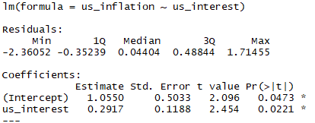

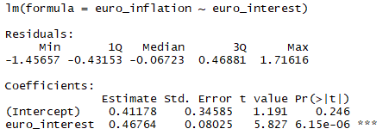

As we can see from the models above the relationship is very significant as interest explains inflation, which is expected as interest rates do have a direct relationship with inflation in exchange rate mechanics. The importance is that interest still cause a positive inflation as prices go higher through at the same time as interest rates rise, but it is relatively negligible. Interest rates are impacted by inflation to compensate risk.

Consumer Spending:

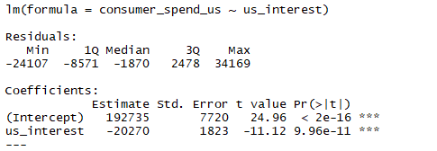

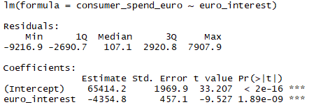

For the above two models, we see the factor is very significant on its own with a negative correlation between the variables. This also is intuitive because as interest rates rise, consumer spending s curtailed. Houses and large purchases that require borrowing are less active in high interest rate environments. Otherwise, as interest rates have fallen over time the US and European economy have grown.

Capital Spending:

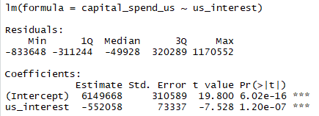

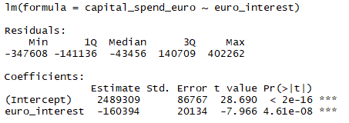

Capital spending is similar in behavior to consumer spending and follows the same relationship with respect to interest rates. As interest rates rise, the level of capital spending falls and the opposite holds. Capital spending is definitely more sensitive to rates as it requires more borrowing efforts than in the consumer goods space.

For reference in these models there are different levels of estimate coefficients. This is due to inputs used and show relationships in the model but not between models.

Full Model:

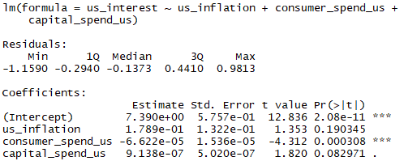

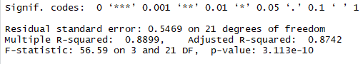

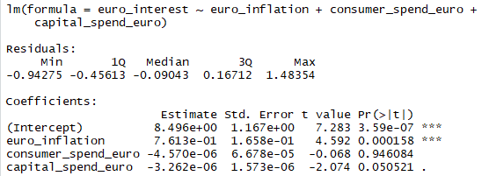

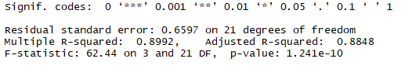

Above we see the two graphs if we alter the code to have the response variable to be interest rates and the other factors as explanatory variables to understand if there is any significant two-way relationships in place. It would not be too good to have a model with multiple items in the response variable at once as there is heavy multicollinearity in place (discussed later). The only contender for a two relationship is inflation as impacting the behavior of interest rates. This makes sense in practice as high inflation prompts action at the Federal Reserve to raise interest rates. Otherwise, the data supports that the other factors are most likely one-way interactions. Consumer and capital spending are sensitive to interest rates but the rates are not impacted by them.

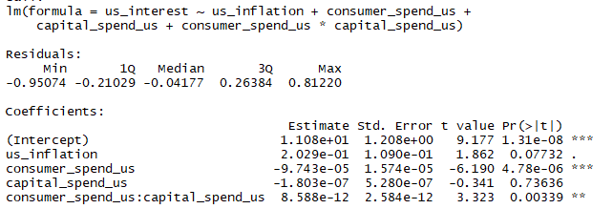

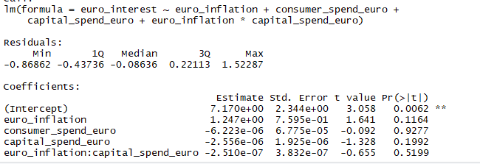

Through investigation, I found for the US model there was an interaction between US capital and consumer spending and for the Euro market there is a relationship between inflation and capital spending so I developed a full model with interaction terms included. There is definitely significance between consumer and capital spending for the US, which is reasonable at a macro level. Expansions usually impact both factors and interest rates are tied to those economic cycles. Otherwise there could be a tie between inflation and capital spending but it is not supported in this analysis. Inflation could have been a factor on spending but only for a specific time period. With inflation being low for a long time and fluctuations in capital spending occurring, its fair to ignore the interaction term as being very important here.

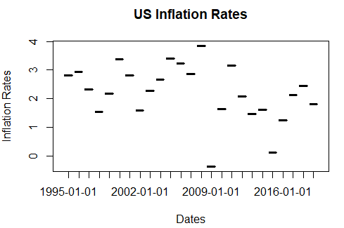

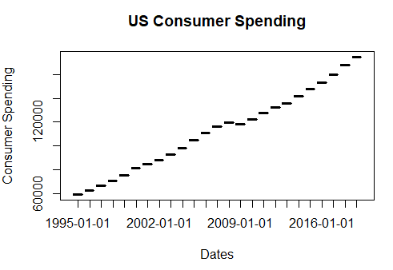

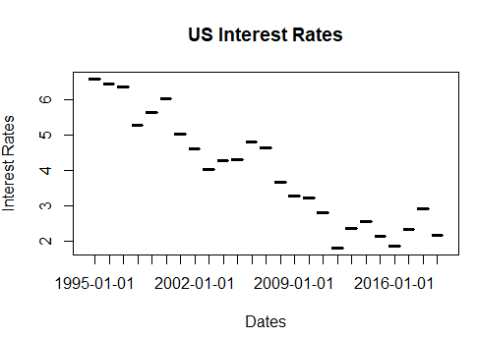

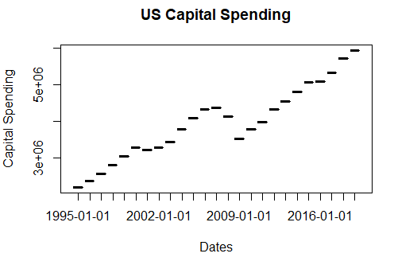

Above are the four US graphs of the factors over time. Spending has increased, interest rates have fallen and inflation rates have slowly fallen but have a wider variance in play.

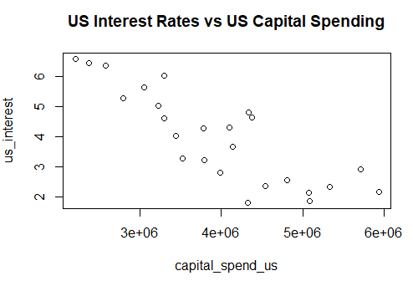

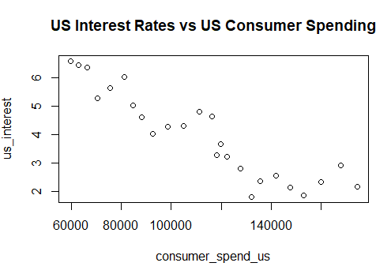

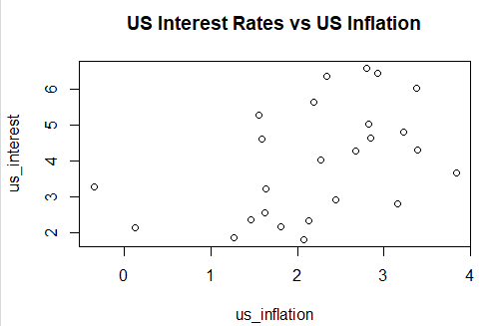

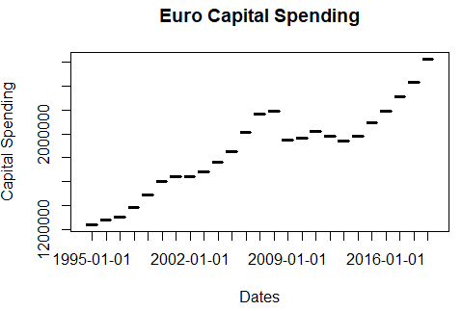

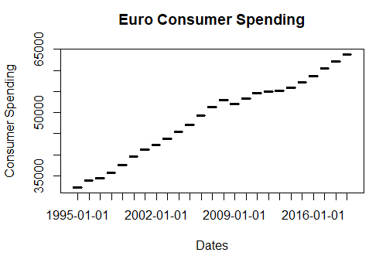

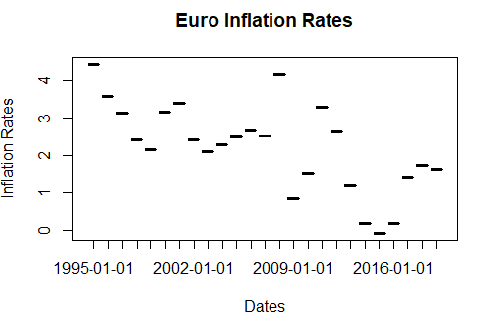

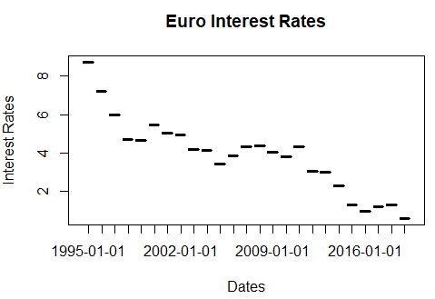

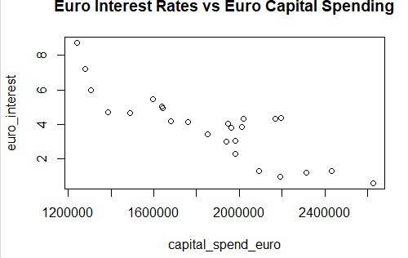

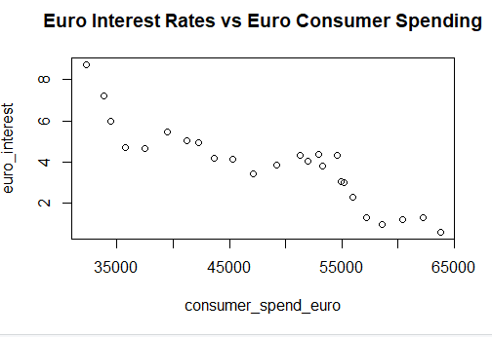

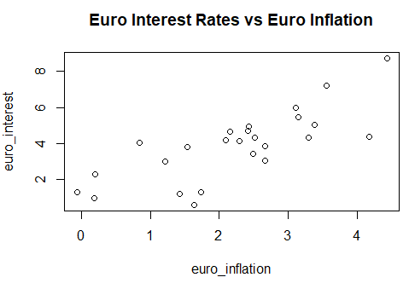

The graphs support the conclusions found earlier that interest rates have an inverse relationship to spending and this is carried out across the economy. Otherwise, inflation has a loosely positive correlation in place. This is established, but its important to note that if a liquidity trap was occurring, we would see the relationship have breaks for these factors. This has not appeared to occur and there is a long-term trend that falls into place that the monetary policy is working as intended for Europe and the US. Below I supported residual models and wanted to introduce a substitute fourth factor that see if the trends still occur and to try to circumvent any unintended multicollinearity of the original factor in question with the other factors.

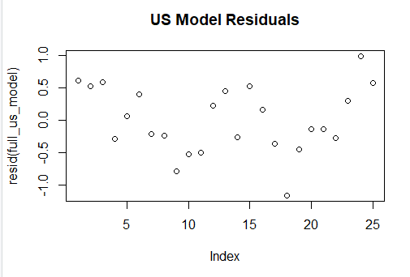

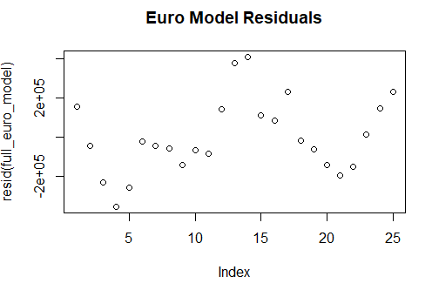

Both the US and the European markets have similar components of their residual models that are stationary in appearance. There is no apparent deviations or trends in the residuals. There are some outliers but it is contained quite well around 0. This supports using linear regression as a tool to determine the validity of our analysis.

Follow Up – Additional Factor

An additional factor is introduced to see if any results change as consumer spending is multicollinear with other factors in both models. The introduced indicator, aggregate personal savings rate, is valuable and slightly different than consumer spending and worth investigating. Consumer savings measures if the low interest rates effectively entice the populace to spend and spur economic growth. Higher savings rates support that consumers are not correlating decreasing rates with higher spending and instead choosing to save reserves.

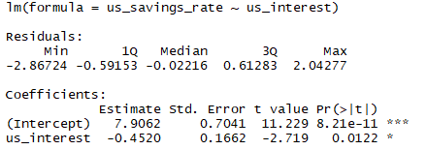

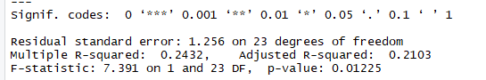

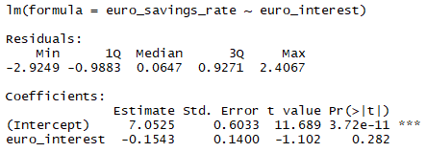

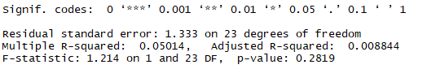

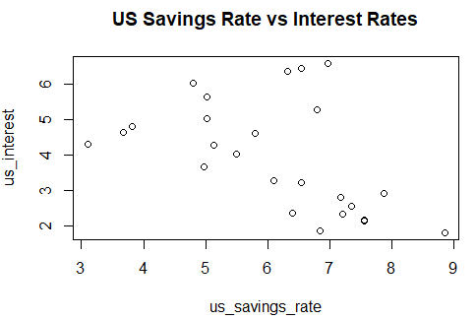

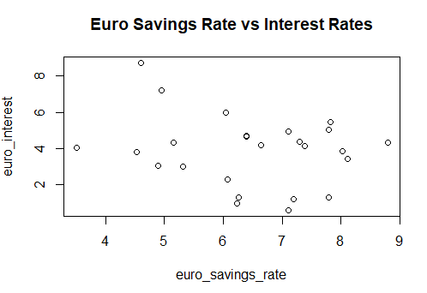

The data and graphs above are different in terms of relationships than the other factors reviewed. Notably, for both the US and Euro markets the models have a very low R^2 with graphs that don’t support relationships between variables. This supports whatever conclusion this model supports, it is tentative at best. I believe this occurs because interest rates don’t have a strong correlation to savings in an economy as other factors have a stronger relationship to this indicator instead. Below are two models that are full with substitution for the switched in factor.

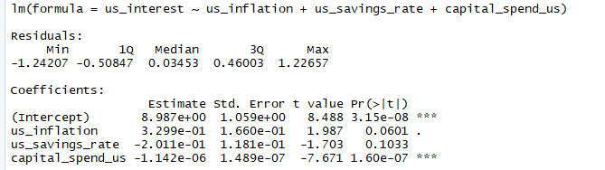

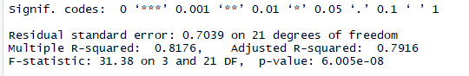

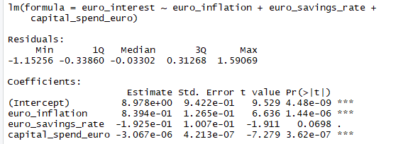

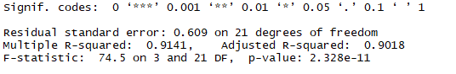

These two models support a better interpretation of model results than the previous two models. The data supports if the new indicator is included the model useful as a measure, but for both we can see savings rates is not significant as a factor here. Given these results, it is preferable to use the earlier models with consumer spending factored in, not savings rate factored in.

Conclusions

Given the data and analysis developed, we can make a strong interpretation with regards to a liquidity trap for the US and the European markets. In the event of a liquidity trap, the indicators would support low interest rates would have a high savings rate and lower or flat changes to capital spending/consumer spending over time. Rates are confirmed as falling over 1995 to 2019 without question but we see that for both markets there is a significant result that responses to interest have resulted in the expected outcomes in both cases. This supports a partially confirmed hypothesis. Both US and European markets fail to show signs of a liquidity trap, which is what I expected for US statistics but not European statistics.

There could be further investigation into recent data, possibly the last 3 years or so to see if the results are different for a recent threat of low interest rates being ineffective. Otherwise, data going forward could investigate if other factors could be used to measure a liquidity trap. A good indicator might be the rate of borrowing. Data from places that do have a liquidity trap in recent history, particularly Japan, could be compared against one of the two markets seen here. That may change how the data is viewed.

The data here is important from an investment decision as discussed in the project prompt. The conclusion is that the two markets don’t have supporting evidence that there is a liquidity trap in effect has a strong implication from an investment perspective. The analysis here supports that if there is expectation for continued interest rates at a low level, then it means the economy will grow as expected. Low interest rates and an active Federal Reserve will lift asset prices and support going long on different assets of a portfolio that are cyclical rather than defensive. Assets like housing or with a customer base that borrows heavily for purchasing goods (i.e. John Deere) will see growth as customers see value in spending rather than saving. If the work here holds, an asset manager of any kind will see value in implementing the conclusions found.

Data Source: Fred Fed (https://fred.stlouisfed.org)